Unit 8 Review Name___________________________________________

Secondary Math 3

Simplify the following radicals.

1.  2.  3.  4. 

Multiply the following radicals and SIMPLIFY.

5.  6.  7. 

Use the division property of radicals to simplify.

8. 9.  10. 

11.  12.  13. 

Convert into radical form and SIMPLIFY.

14.  15. 

16.  17. 

Convert into exponential form. You do not need to simplify.

18.  19.  20.  21. 

Solve for x.

22.  23.  24. 

25. 

26. 

Based on the graph, are the following functions one to one?

[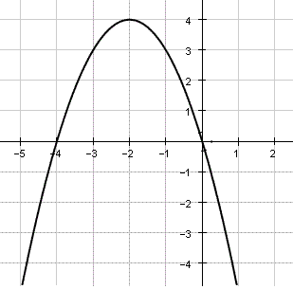](http://www.analyzemath.com/college_algebra/problems_1.html)

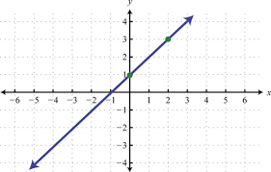

Find the inverse of the following function.

27.  28. 

29.  30. 

31. 

State the transformations graph and state the domain and range.

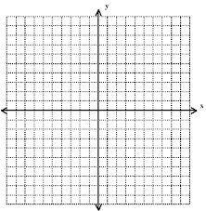

32. 

Transformations:

Domain:

Range:



33. 

Transformations:

Domain:

Range:



34. 

Transformations:

Domain:

Range: