Unit 3 Review Name: ________________________________

Secondary III Date: _________________ Class:_________

1. Are (x+2) and (x-6) factors of ?



Find **all** the factors and zeros of the following functions.

1.  3. 

4.  5. 

Given the following zeros and multiplicities, write a function in factored form

6. 2 (multiplicity of 3), 5, 7(multiplicity of 2) 7. 4, 2(multiplicity of 5), -3

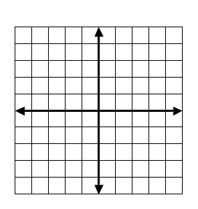For the following functions, find the zeros, state the multiplicity at each zero, state the end behavior, and sketch a graph by hand.

8. 

|  |  |  |
| --- | --- | --- |
| Zeros | Multiplicity | Intersection |
|  |  |  |
|  |  |  |

End Behavior:

9. 

|  |  |  |
| --- | --- | --- |
| Zeros | Multiplicity | Intersection |
|  |  |  |
|  |  |  |
|  |  |  |

End Behavior:

For the following functions graph on your calculator, state the zeros and multiplicity, write in factored form, and analyze.

10.  11. 

|  |  |  |
| --- | --- | --- |
| Zeros | Multiplicity | Intersection |
|  |  |  |
|  |  |  |
|  |  |  |

|  |  |  |
| --- | --- | --- |
| Zeros | Multiplicity | Intersection |
|  |  |  |
|  |  |  |
|  |  |  |

Factored form: Factored form:

Domain: Domain:

End Behavior: End Behavior:

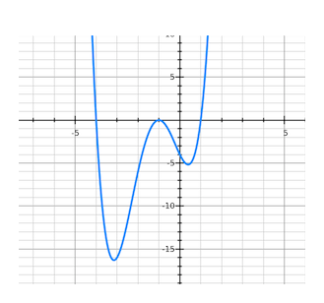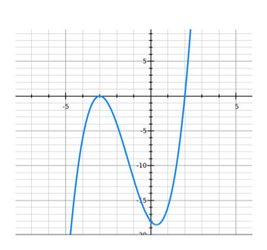Write an equation in factored form to represent the following graphs

12. 13.

14. Is (x-2) a factor of ?

15. Is (x+5) a factor of 

16. Find the interval where 

17. Find the interval where