HW 8-5 Inverses Name: ________________________________

Secondary III Date: _______________ Class: ___________

Determine whether the following functions are one-to-one. If so, sketch a graph of the inverse on the same graph.

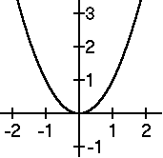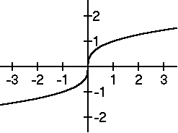

1. 2.

Find  for each of the following and state the domain of  including any inherited restrictions from f(x).

3.  4. 

5.  6. 

7. 

8. Which function is the inverse of ?

a.  b.  c.  d. 

9. Which function is the inverse of 

a.  b.  c.  d. 