HW 8-4 Solving Radical Equations Name______________________________________

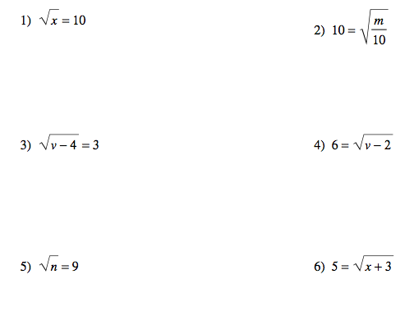

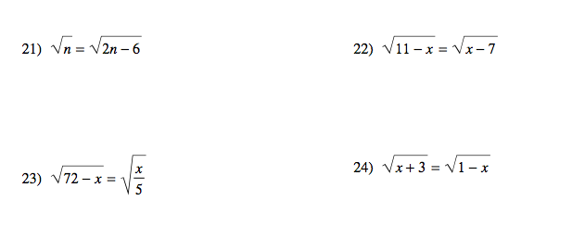

25.  26. 

27.  28. 