HW 8-3 Rational Exponents Name_________________________________

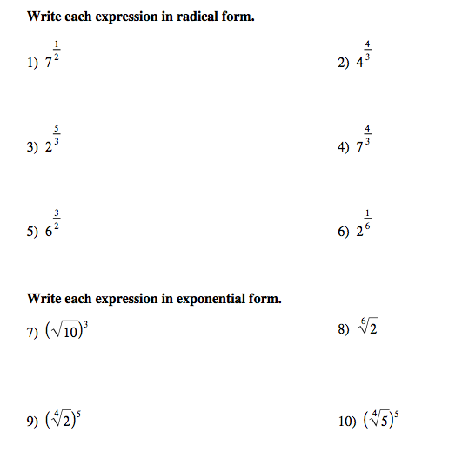

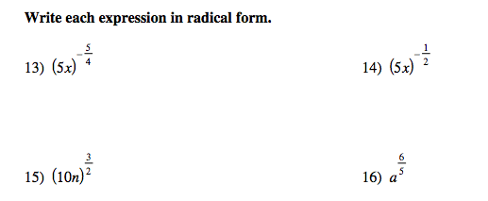

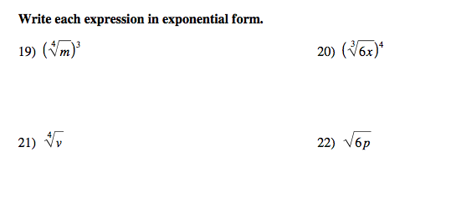

Simplify the following expressions

23.  24. 

25.  26. 