Secondary III 7-4 HW Name______________________________

List the transformation of the following functions.

1. 

2. 

3. 

4. 

Identify the transformations. Then graph the function and state the domain and range.

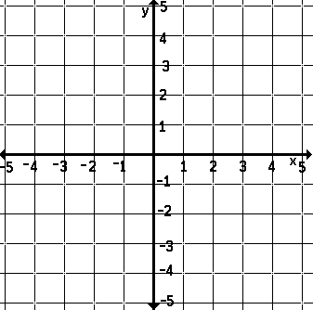

1. 

Transformations:

Domain:

Range:

2. 

Transformations:

Domain:

Range:



3. 

Transformations:

Domain:

Range:



4. 

Transformations:

Domain:

Range: