HW 8-3 Name: ________________________________

Secondary III Date: __________________ Class: ________

Solve the following equations graphically

1.  2.  3. 

Solve the following equations algebraically

4.  5. 

6.  7. 

8.  9. 

10. The price *P* of a gallon of gas after *t* years is given by the equation *P* **=** *P0* ( 1 **+** *r* )twhere *P0* is the initial price of gas and *r* is the rate of inflation. If the price of a gallon of gas is currently $3.25, how long will it take for the price to rise to $4.00 if the rate of inflation is 10.5%?

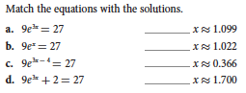

11