**6-5 Graphing Exponentials**

Macintosh HD:Users:smccartney:Desktop:Screen Shot 2014-12-15 at 8.34.00 AM.png

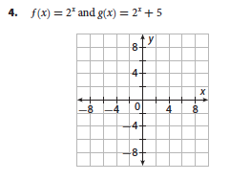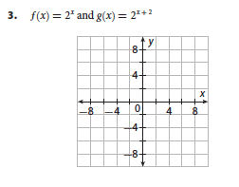

Domain: Domain:

Range: Range:

Y-intercept: Y-intercept:

5.  6. 

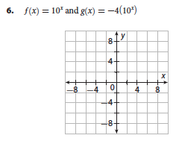

Domain: Domain:

Range: Range:

Y-intercept: Y-intercept:

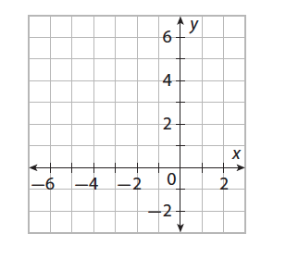

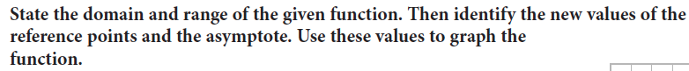

11. 

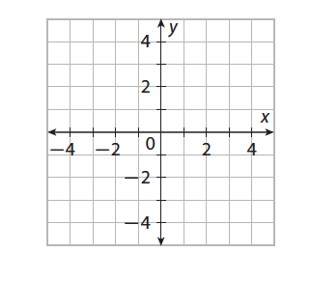

15. 

Macintosh HD:Users:smccartney:Desktop:Screen Shot 2014-12-15 at 8.43.19 AM.png

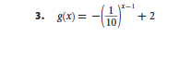

Transformations: Transformations:

Domain: Domain:

Range: Range: