HW 5-2 Graphing Transformations Name_______________________________

Secondary 3 Period_______________

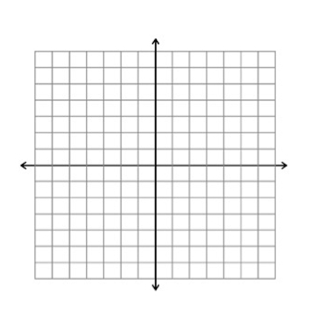Rewrite the function in the form f(x) = q(x) + $\frac{r(x)}{d(x)}$, then write the transformations from its parent function and sketch a complete graph of f(x).

1. f(x) = 2. g(x) =





3. h(x) = 4. j(x) =

7.  8. 



9.  10. 