HW 5-2 Name: ________________________________

Secondary 3 Date: ________________ Class: __________

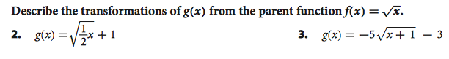

Macintosh HD:Users:jessicaberry:Desktop:Screen Shot 2015-03-12 at 10.49.29 PM.pngDescribe the Domain and Range of each function

Macintosh HD:Users:jessicaberry:Desktop:Screen Shot 2015-03-12 at 10.49.23 PM.png

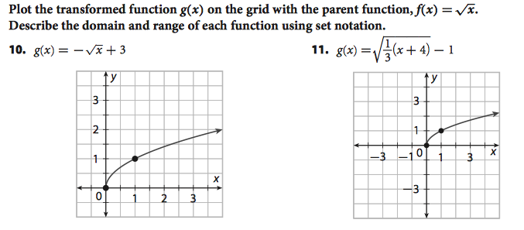

Write a function to represent the following graphs

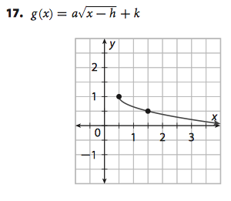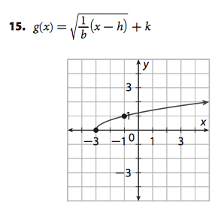

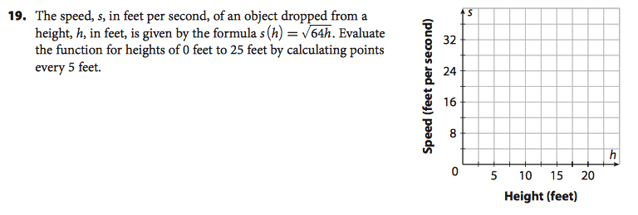

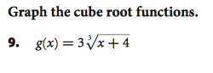

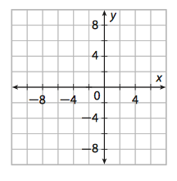Macintosh HD:Users:jessicaberry:Desktop:Screen Shot 2015-03-12 at 10.57.10 PM.png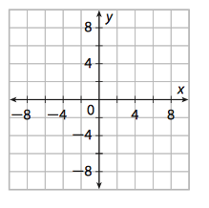

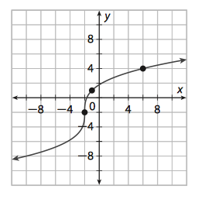

11. Write an equation to represent the

following function

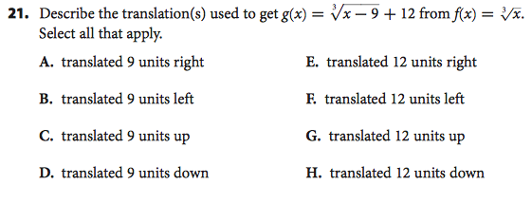

**Selected Answers**

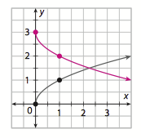7. D:  R: 

10.

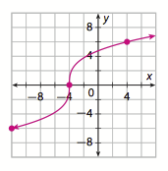17. 

9.