Graphing Polynomials

Use a graphing calculator to graph the polynomial function. Then use the graph to determine the function’s domain, range, and end behavior. (Use interval notation for the domain and range.)

1.  2. 

**3. 4. **

Use a graphing calculator to graph the function. Then use the graph to state the zeros and multiplicity of each zero.

5.  6.

|  |  |  |
| --- | --- | --- |
| Zero | Multiplicity | Intersection |
|  |  |  |
|  |  |  |
|  |  |  |

|  |  |  |
| --- | --- | --- |
| Zero | Multiplicity | Intersection |
|  |  |  |
|  |  |  |
|  |  |  |

7.  8. 

|  |  |  |
| --- | --- | --- |
| Zero | Multiplicity | Intersection |
|  |  |  |
|  |  |  |
|  |  |  |

|  |  |  |
| --- | --- | --- |
| Zero | Multiplicity | Intersection |
|  |  |  |
|  |  |  |
|  |  |  |

Sketch a graph of the polynomial function.

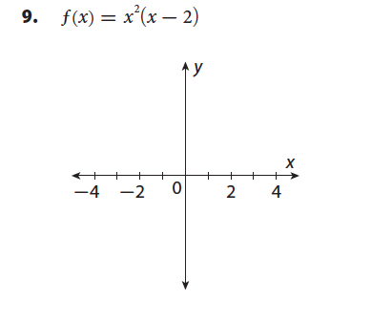

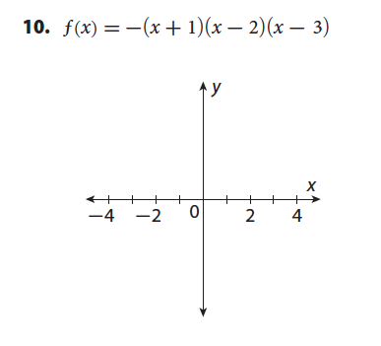

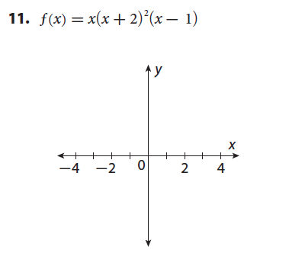

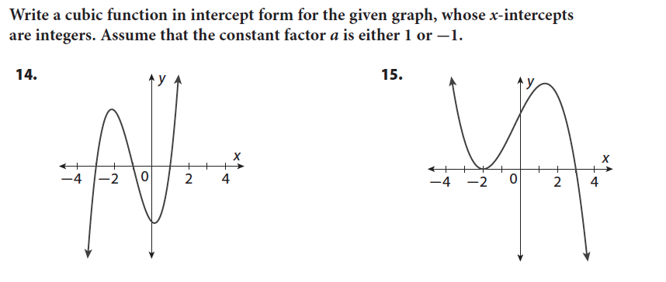

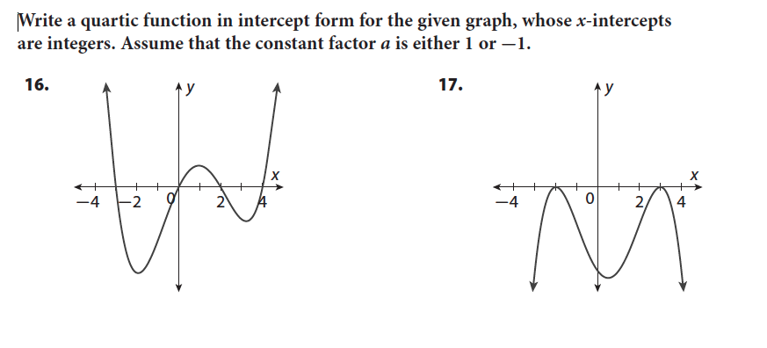

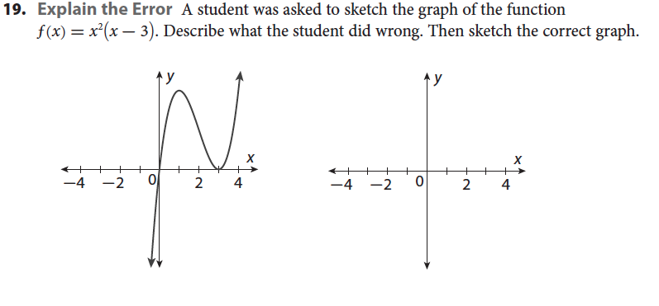

Selected Answers:

1. Domain: 

Range: 

End Behavior:

As 

As 

3. Domain: 

Range: 

End Behavior:

As 

As 

5. 0 multiplicity 1,

-3 multiplicity 1,

-1 multiplicity 1

7. 0 multiplicity 1,

2 multiplicity 2

9.

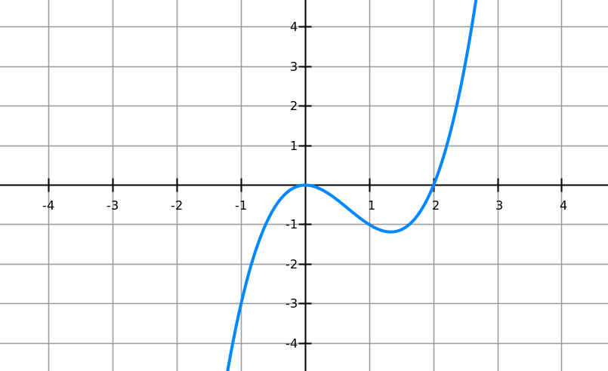

11.

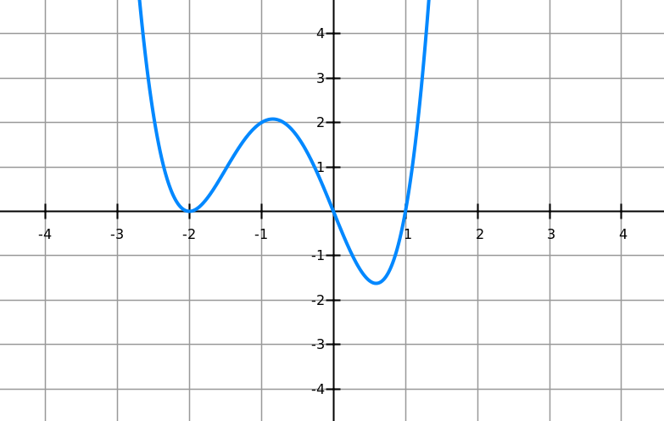

14. 

17. 

19. The student has the graph crossing at x=0 and tangent at x=3 when it should be tangent at x=0 and cross at x=3. (Actual graph on next page)

