Secondary Math III Name:_________________________________________________

HW 10-1 Period:_____________

Book 17.1

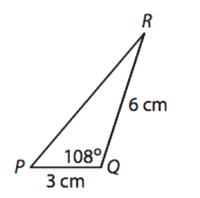

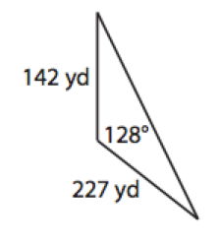**Find the area of each triangle to the nearest tenth.**

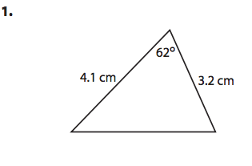 **2. 3.**

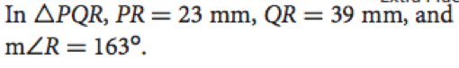**4.**

**Find the exact value. Find ALL possible solutions.**

**5.  6. 7.  8. **

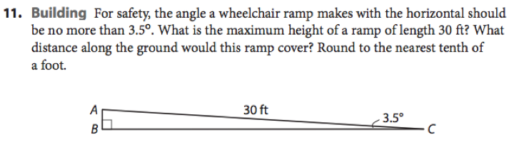

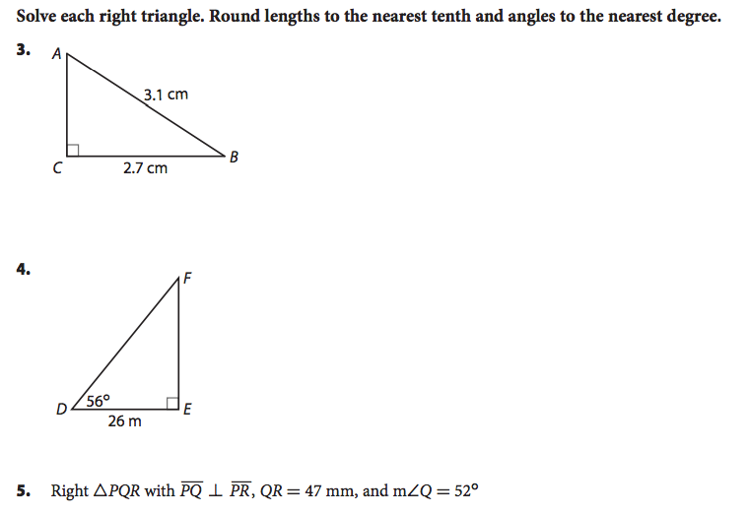

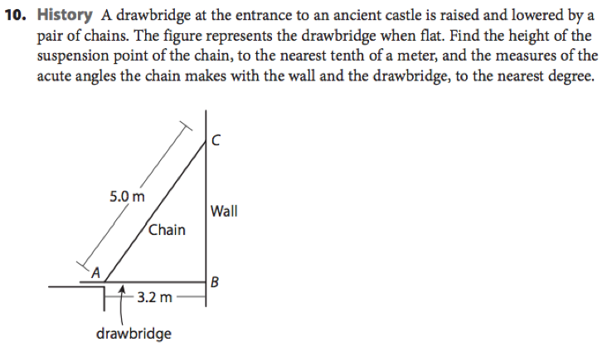

Selected Answers:

2. A = 8.6 cm2

4. A = 131.1 mm2

6. 

8. 

4. F = 34°

d = 38.6 m

e = 46.5 m

10. a = 3.8 m

A = 50°

C = 40°