HW 1-2 Name:_________________________________________________

Transformations Period:_____________________

Graph the parent function. Then for the second function, state the transformations, then graph.

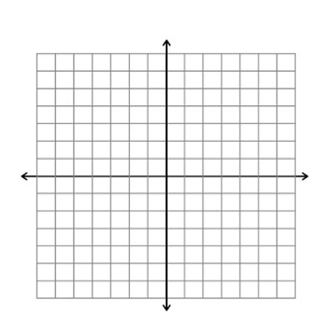

1.  2. 

Transformations:



3.  4. 

Transformations:



5.  6. 

Transformations:

7.  8. 

Transformations:





9.  10. 

Transformations:



11.  12. 

Transformations:



13.  14. 

Transformations: