HW 9-1 Name:_________________________________

Period:__________

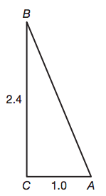

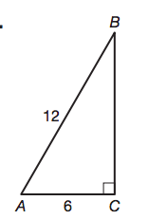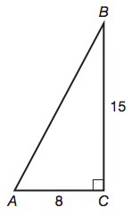**Find the missing side length:**

1. 2. 3.

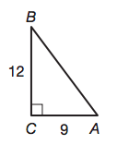**Find all trigonometric functions for angle A in problems 7-8:**

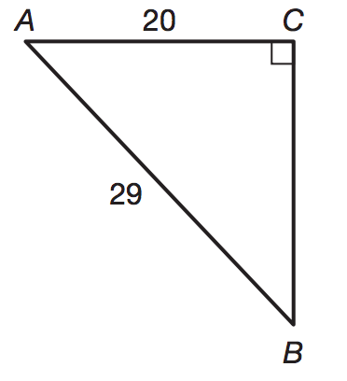

7. 8.

**Find all trigonometric functions for the given triangles for angle  .**

9. 10. 11.

5  13

3 1 5







4 1 12

**Evaluate using a calculator. Round to 3 decimal places.**

12. sin 23° 13. cos 59° 14. tan 87° 15. sin 4°

**Set up and use trigonometric ratios to find the missing values.**

14. 15.

16. The angle of elevation from the base of a waterslide to the top is about 13. The slide extends horizontally (along the ground) about 58.2 meters. How tall is the slide?

11. A standard baseball diamond is a square with 90 foot sides. How far must the first baseman be able to throw to get someone out on third base? Give answer to the nearest tenth of a foot.

12. You are painting a mural on a wall 18 feet high. So the ladder is stable, is must be placed 6 feet away from the wall. To the nearest foot, how tall must the ladder be?